Screenshot 1: Console- deposit & withdrawal output, flagged deposit/withdrawal transactions, audit.

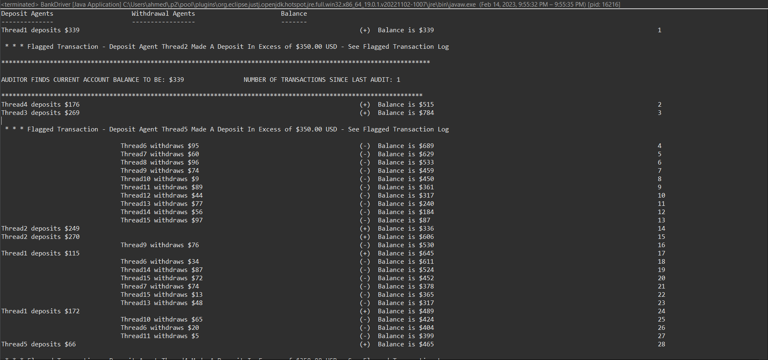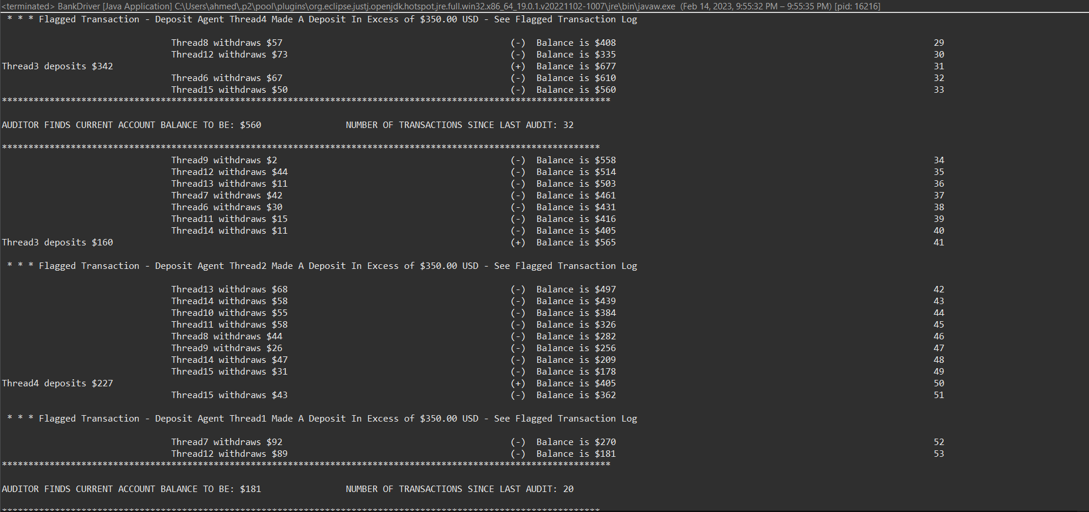

Blocked withdrawal threads once balance hits $0

Transactions.txt